**EE 2305 – Introduction to C Programming**

**Hardware Project 02**

**7-Segment Display**

Project Features: Digital Input and Digital Output.

Program an Arduino board to accept a 4-bit binary input and display the numerical value (0 to 9) on a 7-Segment LED display.

Use the pushbutton for the digital input:



Use the 7-Segment LED Display:



Pin 1

Pin 5

Pin 10

Pin 6

To document your program, create a document and include the following sections in the document. Provide a brief description of the system and how you are designing it to operate,

**A. Hardware Diagram:**

Provide a hardware diagram of the components.

Analog Input

13

12

~ 11

~ 10

~ 9

8

7

~ 6

~ 5

4

~ 3

2

TX 1

RX 0

3.3V

5V

Gnd

Gnd

Vin

A0

A1

A2

A3

A4

A5

Power

Digital Input / Output

Arduino UNO

Hardware Diagram

**B. Program Flowchart:**

Draw a flowchart of the program using the Word graphics shapes.

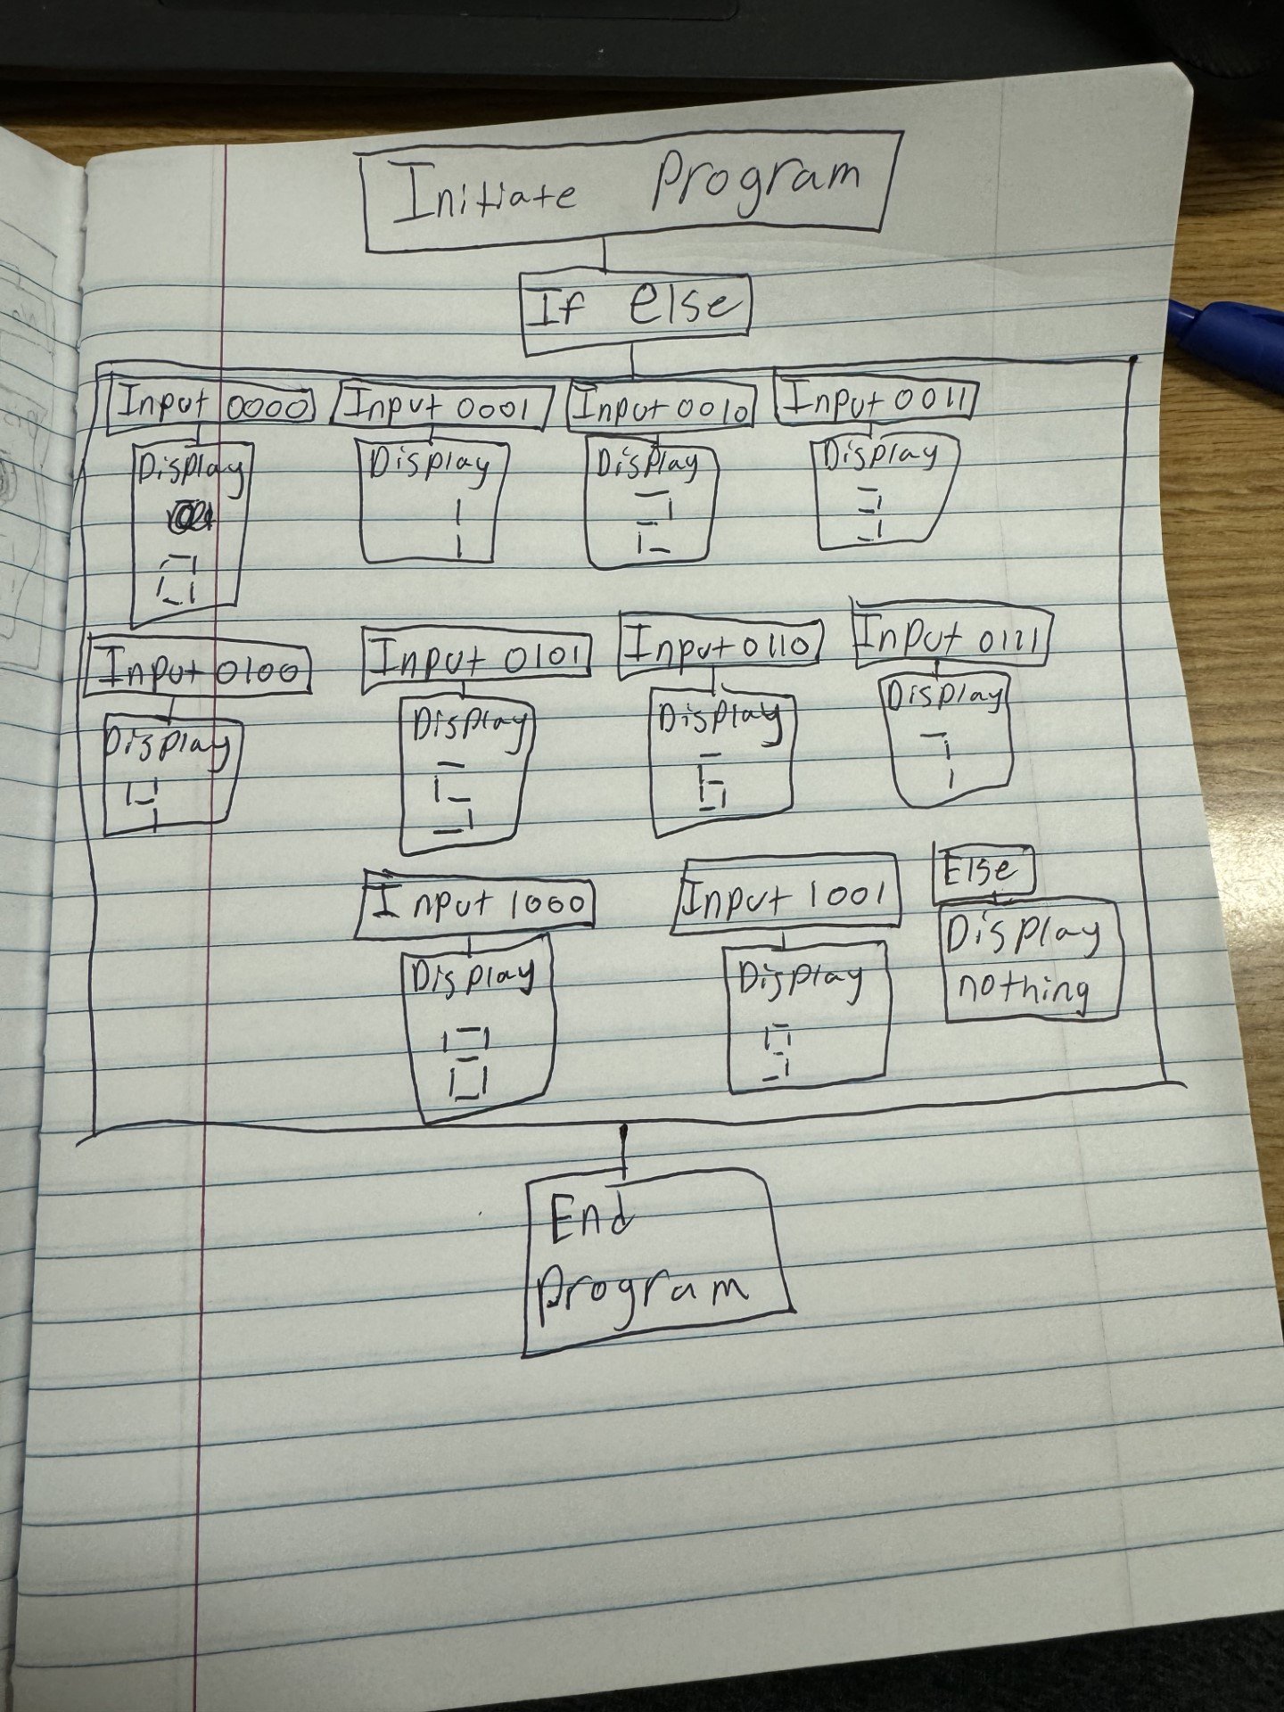

**C. Arduino Source Code**

Insert the Arduino Source Code into the document.

**D. Demonstration Video**

Record and upload a video demonstrating the operation of the circuit.

[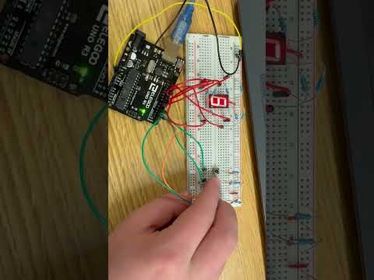](https://www.youtube.com/embed/2Z63S8b1Oec?feature=oembed)

Save the document as a *PDF* file and submit the *PDF* document to *Blackboard*.